AI IN MEDICINE · SEMESTER 5 · COURSE PROJECT PROPOSAL
What Should Adaptive Cancer Therapy Optimise?
A controlled cross-evaluation of reinforcement-learning reward objectives
Arnav Kumar MD24B003 · Rohit Satish Chipde MD24B026 · Dept. of Medical Sciences & Technology, IIT Madras
1. Clinical problem. Continuous maximum-tolerated-dose therapy kills drug-sensitive cells quickly and, in clearing them, releases a pre-existing resistant clone from competition - competitive release, the dominant failure mode of systemic therapy. Adaptive therapy instead withdraws the drug once the burden falls, retaining sensitive cells to competitively suppress resistance, containing the tumour rather than racing to eradicate it. A prospective pilot in metastatic castrate-resistant prostate cancer achieved substantially longer time to progression on roughly half the cumulative abiraterone dose (Zhang 2017; eLife 2022).
2. Research problem. Six published studies each optimise a different reward objective - survival with drug holidays, dose and duration, coexistence, durability, inverse fitness - each in its own simulator, and none compares its objective against another. We ask: does the choice of reward objective change the treatment policy, and if so, by how much and at what cost on the objectives it was not trained for?
3. Why it matters. If the objectives converge, the field’s reward-design debate is decorative, and effort belongs on environment realism. If they diverge, a clinician must know which objective a published policy optimised before trusting it, and that off-diagonal penalty is what no single-objective paper can produce. This is a comparative contribution; PPO is the instrument, not the novelty claim.
4. Environment. No real patient data is used. We adopt the Strobl (2021) two-population Lotka–Volterra model with turnover as Gallagher (2023) writes it, fitted to 67 patients and already shared by four RL studies:
$$\frac{dS}{dt}=r_{S}S\left(1-\frac{S+R}{K}\right)\left(1-d_{D}D\left(t\right)\right)-d_{T}S \frac{dR}{dt}=r_{R}R\left(1-\frac{S+R}{K}\right)-d_{T}R \text{Prog.: }N≥1.2N_{0}$$
with r_{S} = 0.027/day, d̂_{D} = 1.5, K = 1, n₀ = 0.75, f_{R} = 0.01.
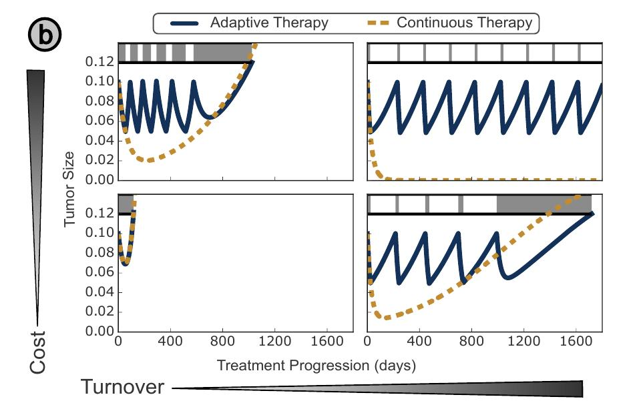  Adaptive (solid) vs. continuous (dashed) therapy, across increasing turnover (left to right) and cost of resistance (top to bottom). From Gallagher et al., bioRxiv 2023.04.28.538766, CC BY-NC 4.0. | The environment is specified in two tiers. E-base is fully observed, deterministic and binary-action. E-ext adds graded dosing (0, ½, full), observation only every 28 days with measurement noise, and a patient for whom the cost of resistance and turnover are unknown to the agent.  Training uses a 3 × 3 virtual cohort with costs {0.10, 0.26, 0.42} and turnovers {0.01, 0.03, 0.05}, not a single patient. The figure is why: whether adaptive therapy helps at all, and by how much, depends on where the patient sits in that plane.  A policy - and a comparison of objectives - is reported for one patient, and nothing in the results indicates which panel the next patient occupies.
5. AI task, and why reinforcement learning. Sequential decision-making under a partially observed Markov decision process; the reward function is the variable under study. On E-base, value iteration returns the exact optimum, so we use it as a per-objective optimality ceiling rather than a competitor — the claim becomes “reached 96% of the computable optimum for its own objective”, not “beat AT50”. On E-ext, the agent acts on a belief over unknown patient parameters, where exact dynamic programming is intractable and recurrent PPO is the available instrument. Progression is checked at every integration step, not only at decision points.
6. Objectives compared. R1 (Gallagher 2023/24, the field default): +0.1 per timestep survived, +0.05 per timestep off treatment, −0.1 on progression, γ = 0.999. R4 (Yao 2024, durability): the same survival and progression terms, with a terminal penalty on resistant regrowth over a 180-day simulated withdrawal. The two share every term but the third, which isolates the variable under study. A faithful entropy/coexistence port was rejected as the second arm: on two populations, its maximum sits at 50% resistance, so divergence would be guaranteed by a porting artefact.
7. Baselines and benchmark. No treatment, continuous MTD, AT50, a tuned AT-x sweep over {25, 50, 75, 90}%, fixed 30/30 intermittent, AT-PSC (Ma 2026), and the per-objective value-iteration ceiling — beating MTD is necessary but not sufficient. Our re-implementation already yields 454 days for continuous therapy against a published 451, and 706 against 672 for AT50; Experiment 0 closes the residual gap against published parameters, not by tuning.
8. Evaluation. Time to progression, cumulative dose, mean and terminal resistant fraction, post-withdrawal regrowth and maximum burden, with every agent scored on every metric — the diagonal is circular by construction, and the content lies off it. Two policy-space measures support the divergence claim, since outcomes can coincide while policies differ: the switching threshold N* from a sigmoid fit to P(treat) versus burden, and the pairwise KL divergence between state–action distributions. Median and the full seed distribution are reported, never the mean alone; pre-registered, a difference is claimed only if it exceeds the within-objective seed spread.
9. Outcomes, risks and limitations. Deliverables are a quantified answer in either direction, a correctness-verified two-tier environment with computed ceilings, and a reproducible cross-evaluation pipeline; a null result is reported as the finding rather than buried. Risks carry fallbacks: the benchmark parameters and the Yao reward form are retrieved in Week 1, both currently unverified, and a factor-of-two discrepancy in the drug term has already been caught. We claim no clinical applicability — simulation only, two objectives of at least four, no spatial structure or pharmacokinetics.
References. Zhang, Nat. Commun. 2017;8:1816 and eLife 2022;11:e76284. Strobl, Cancer Res. 2021;81(4):1135. Gallagher, bioRxiv 2023.04.28.538766 and Cancer Res. 2024. Gluzman, Proc. R. Soc. B 2020;287:20192454. Phys. Rev. E 2026;113:064404. Yao, Brief. Bioinform. 2024 and Ma, PLOS Comput. Biol. 2026 — to be verified in Week 1.

